**Questions**

1. **(40 points)** Assume that you have a D-Bot with a mission of drawing a 3.91 meters long straight line. This D-Bot uses small batteries to operate and each battery can be used to travel along a 17 cm-long straight line at most. The D-Bot can carry up to 15 small batteries in its trunk. On the way, it can stop anywhere to leave some of the batteries it carries and come back later to pick them up. There is a stock of 45 batteries at the starting point and no new batteries can be found on the way. If the D-Bot can correctly plan where to leave the back-up batteries to pick them up later, it can draw the full line and complete its mission. You may assume that the empty batteries are dropped off automatically; hence you do not need to think about them. Note that D-Bot also drains the battery even if it’s coming back to pick some other batteries up.

- Describe a strategy that D-Bot needs to follow to complete the mission,

- State at least two of the computational thinking concepts and/or problem solving heuristics that you used to find the solution, and

- Explain how you used these concepts and/or heuristics.

Please note that lack of use and/or explanation for computational thinking concepts and/or problem solving heuristics will result in loss of points even if the solution/strategy is correct.

**ÇÖZÜM:** While dealing with the problem, I used the concept of Computational Thinking methods, Decompozition and Pattern Recognition. The solution is as follows.

We calculate initial informations based on given data for D-bot.

* 1. 3.91/0.17=23 batteries should be used to reach destination.
  2. We have total 60 batteries that 15 batteries in D-bot’s trunk and 45 batteries at the initial point

The D-bot cannot take 23 batteries at a one time and cannot go to the desired distance with 15 batteries. In this case, we need to divide the interval into sub-intervals and create stations between each of them. We have to adjust the number of batteries that should be put in these stations so that after D-bot can go furthest point, it can com back by using them. Also, leave the battery to be used for the last time so that it can take the longest distance.

In this case, the stations should be considered as one by one (Decompozition). According to decompozition phase, problem breaking down into small parts so that we can solve easily each of them. In addition, If we find a pattern that D-bot follows it for every small parts, it’s easy to deal with problem (Pattern Recognition). So how should we do this;

**Step 1**:

At the beginning, how many stations do we need? We have 60 batteries, and since D-bot can carry 15 batteries in each case, in this case, we have 4 tours. The D-boat will have to return 3 times, and the last tour should go directly to the destination. So, we have to create 3 stations. The distance between these stations is not very important. The main point is the amount of batteries left in these stations. As mentioned at the beginning, 23 batteries are required to reach the destination point and the solution should be taken into account this number of batteries.

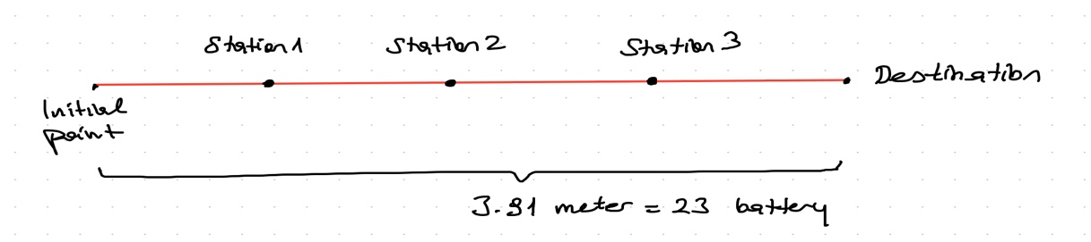

**Step 2:**

So, which factors should be thought for adjusting the number of batteries for each station? Since the D-bot will make 4 trips in total and will not return in the last time. There will be 3 returns in total. Accordingly, he must stop by 2 returns for the first station, 1 return from the 2nd station and continue in the last round with the batteries he left at the last station.

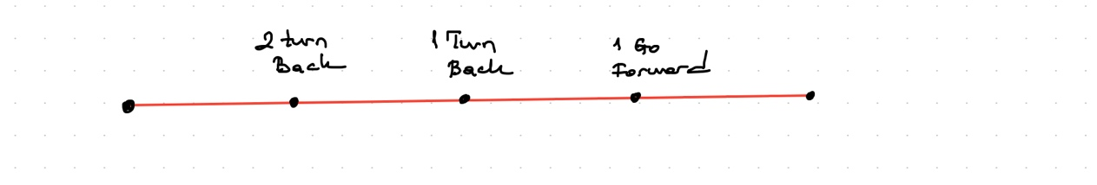

The number of batteries to be left in each station should be determined under these conditions in below;

a. D-bot must use the same number of batteries for return, when it comes to the station,

b. The more batteries it uses for the next station until the previous station, the more batteries should be left.

c. The battery must be left in each station for the last lap.

According to this pattern, each station should be considered separately; (Pattern recognition)

**Step 3:** Planning of Stations

**Round for first Station:**

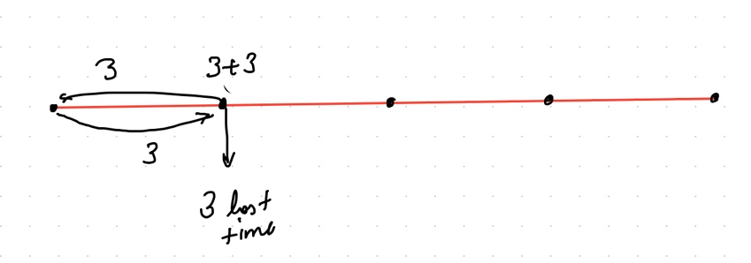

1 group battery for going to station+ 1 group battery for returning+ 2 groups batteries backup for the next two turns+ 1 group battery for the last tour = 5 groups batteries

it has 15 batteries then 15/3=3 batteries for each part. Then 6 (3+3) batteries for two returns + 3 batteries for last lap

**Round for Second Station:**

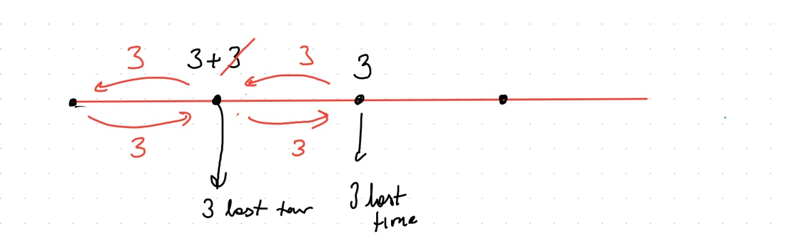

When it comes first station, it has already used 3 batteries. So, it has 12 batteries at the beginning of second interval. 1 group battery for going to second station+ 1 group battery for returning to first station+ 1 group battery backup for the next one turn+ 1 group battery for the last tour = 4 groups batteries. Then 12/4=3 batteries for each part.

**Üçüncü istasyona gidiş :**

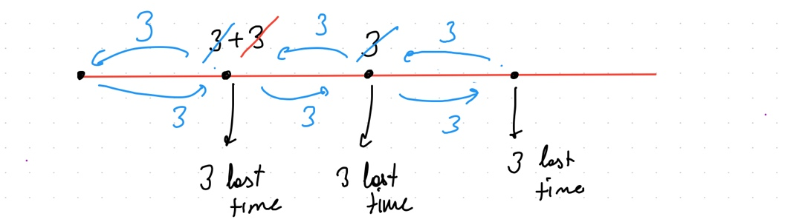

When it comes second station, it has already used 6 batteries. So, it has 9 batteries at the beginning of second station. 1 group battery for going to third station+ 1 group battery for returning to second station+ 1 group battery for the last tour = 3 groups batteries. Then 12/4=3 batteries for each part.

**Final Lap :**

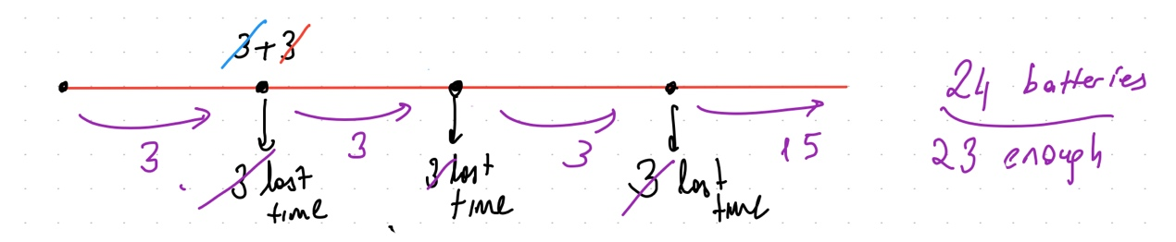

When it comes final lap, every station has 3 batteries. And also, to pass for each interval, it needs three batteries. Therefore, when D-bot comes to third station, it has 15 batteries. Then it can go with 15 batteries after that point. We need 23 batteries in total. And we can reach to the destination

1. **(60 points)** During the break of a two-hour lecture, you wanted to go to the vending machine to get something to eat or drink. The machine has two options: (i) a bottle of water, and (ii) a chocolate bar. You need to choose option-1 for water and option-2 for the chocolate bar. A bottle of water costs 75 Cents and a chocolate bar costs 1.25 dollars. The machine accepts 25 Cents and 50 Cents coins, and it can also give you the change if needed. To get the product, you first need to choose the option you want to buy. Thereafter, the machine shows you the cost of the product, and after that, you should make the payment using coins. The user is free to insert coins of any denomination (25 cents or 50 cents) one by one, and he/she will not necessarily insert the exact amount. The machine keeps accepting coins as long as the total worth of the coins inserted is not sufficient for the requested product. Once the total worth of coins inserted into the machine becomes sufficient for the amount of the selected product, the machine first gives the change (if needed), and then, it gives the product.

Note: 1 Dollar is 100 Cents.

* 1. Write the pseudocode of the algorithm that the vending machine should follow to give you the product, charge the correct amount and give the change back.

* 1. Draw a flowchart for the algorithm that the vending machine should follow to give you the product, charge the correct amount and give the change back.